**Microstructure of tap water sediments on hydrophilic surfaces**

**Supplementary Materials**

(Width of each photo - 3 mm)

**1. Two days of incubation of glass slide in tap water under room conditions**

**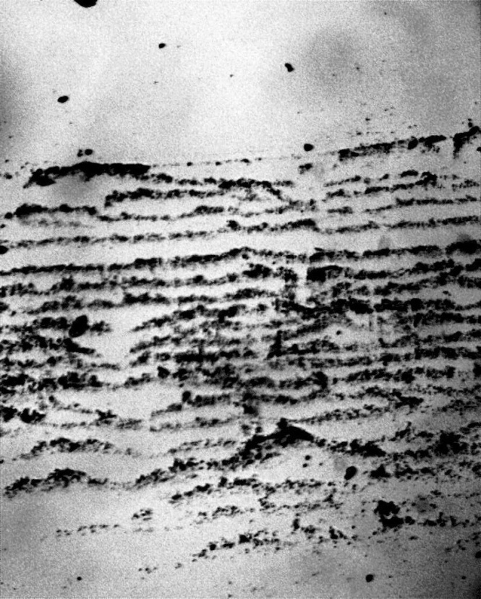**

Figure 1a. Traces of the advance of the drying front on glass immersed in tap water.

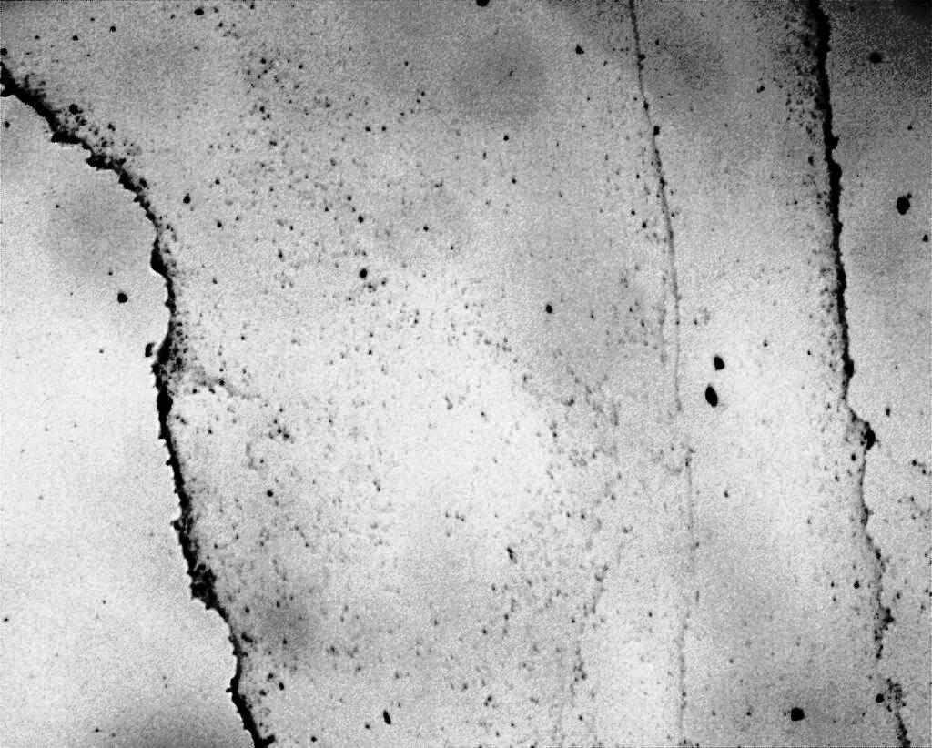

Figure 1b. Sediments of tap water on glass slide.

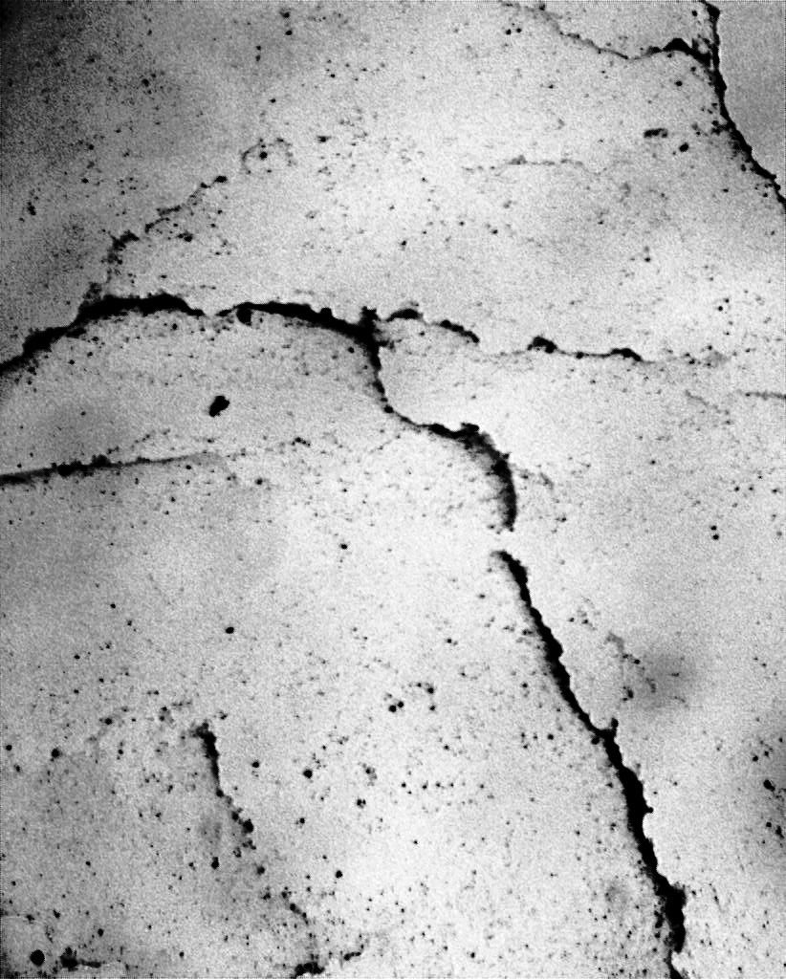

Figure 1c. Multilayer deposits of DP aggregates on glass immersed in tap water for two days.

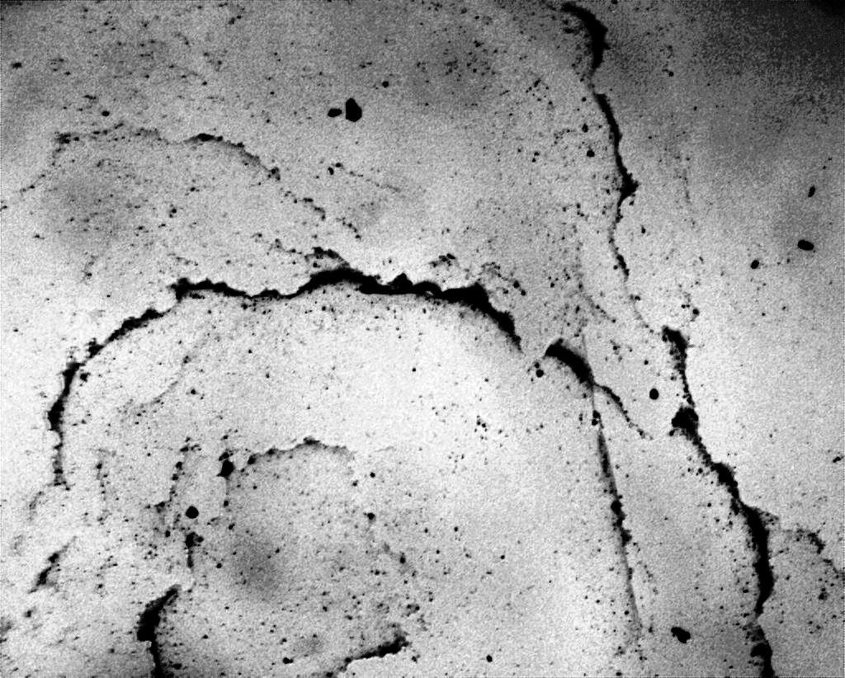

Figure 1d. Multilayer deposits of DP aggregates on glass immersed in tap water for two days.

**2. Sediments at the bottom of a Petri dish after evaporation of free water**

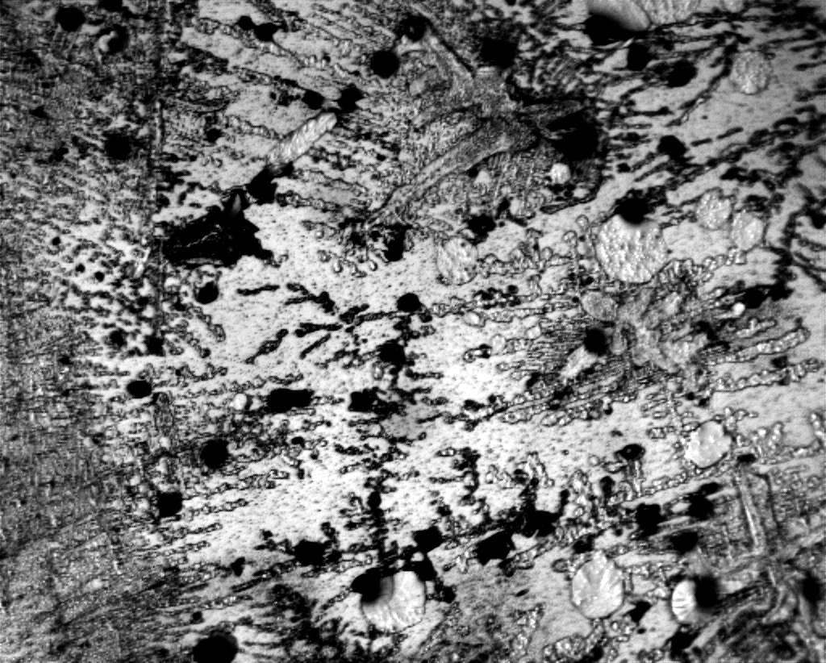

Figure 2a. Islands of DP deposits among various crystal structures.

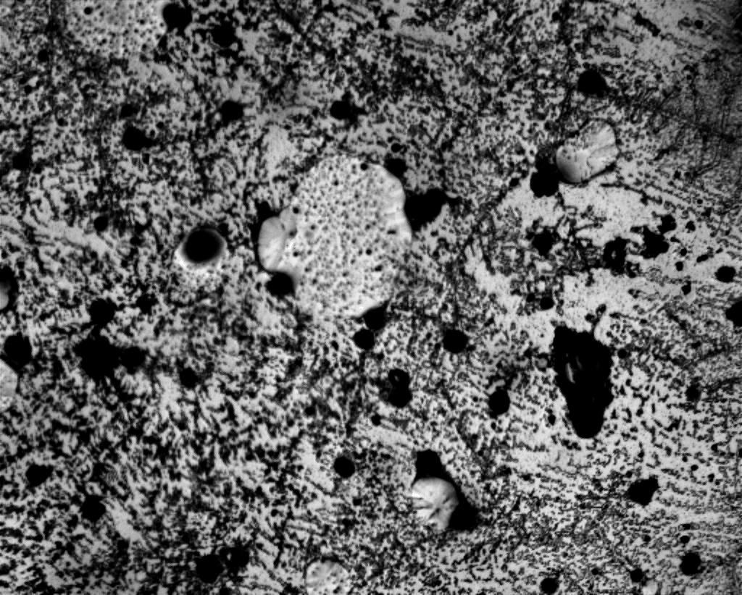

Figure 2b. Islands of DP deposits among various crystal structures.

|  |  |
| --- | --- |
| C:\Users\1\Desktop\Вода_Стекла\Январь 2022\Инкубация стекла Инкубация стекла в воде\Чашки Петри\Впр_3.jpg | C:\Users\1\Desktop\Вода_Стекла\Январь 2022\Инкубация стекла Инкубация стекла в воде\Чашки Петри\Впр_4 - копия.jpg |

Figure 2c,d. Light areas bounded by dark boundaries are DP aggregates with NaCl crystals growing inside them.

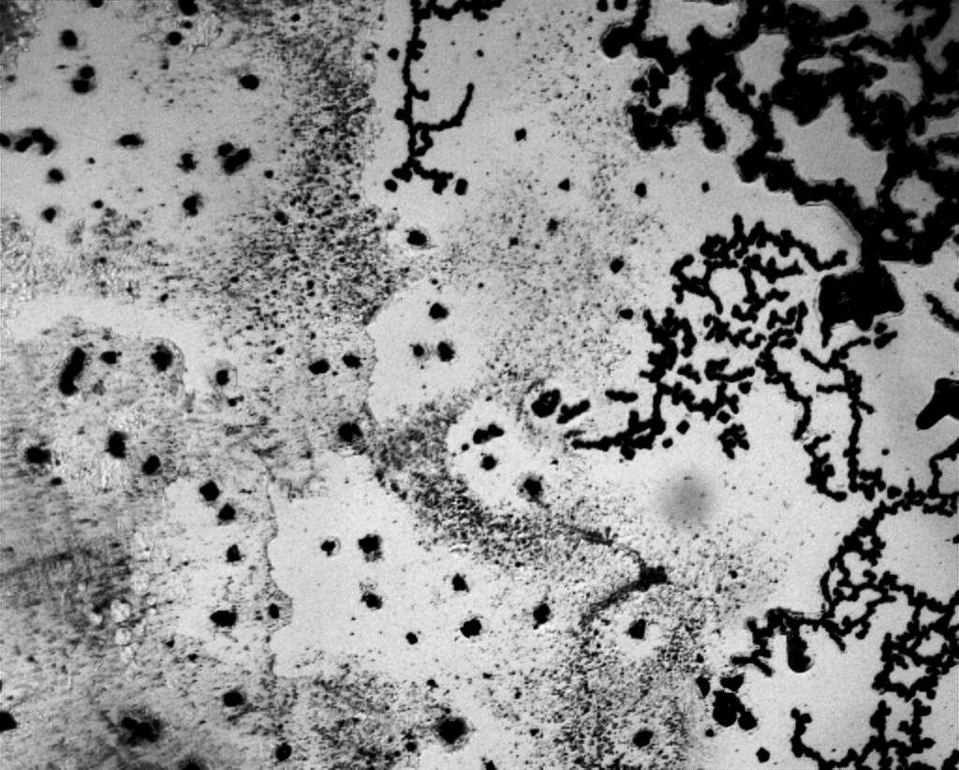

Figure 2e. Fragments of DP with large NaCl crystals growing inside them.

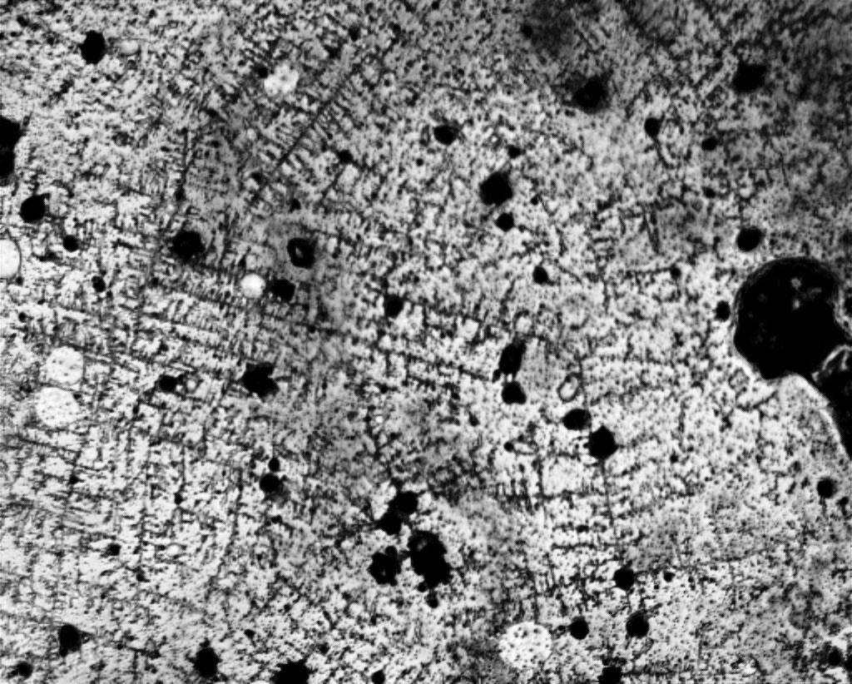

Figure 2f. Fractal salt structures and large NaCl crystals against the background of collapsing hydrated shells of DP.

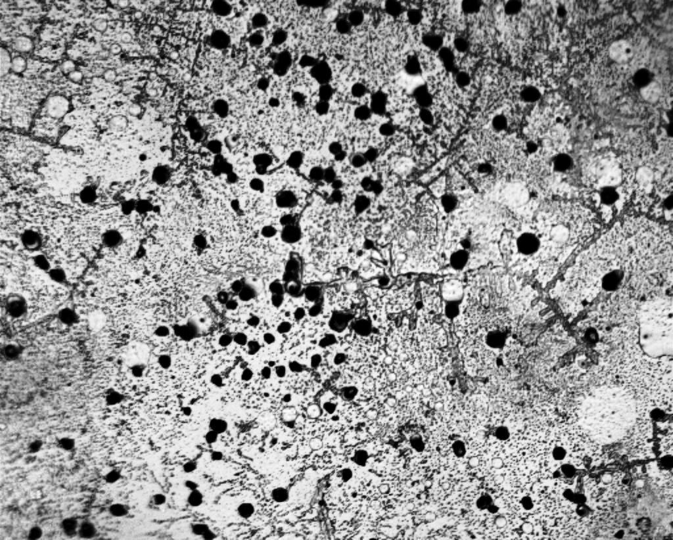

Figure 2g. Large NaCl crystals against the background of collapsing hydrated shells of DP.

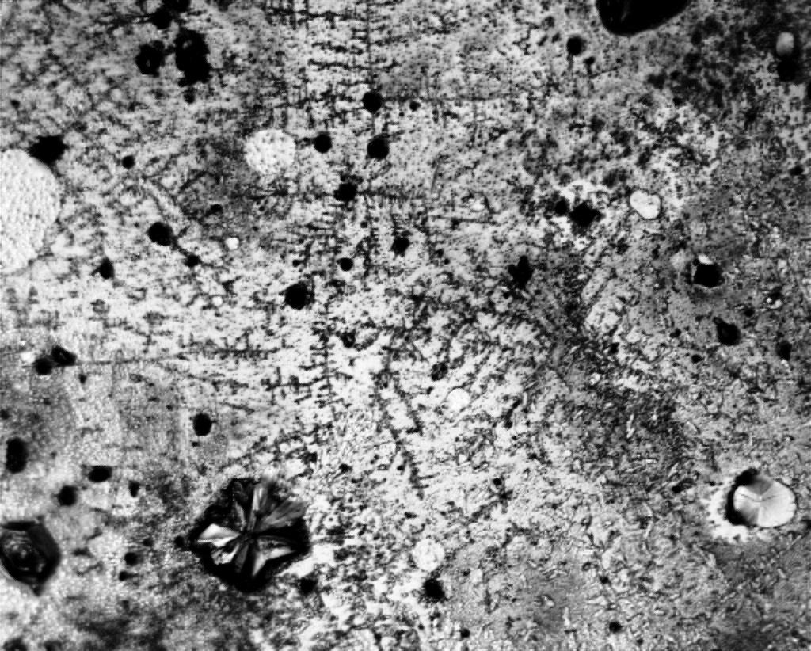

Figure 2h. Fractal salt structures and large NaCl complex crystal against the background of collapsing hydrated shells of DP.

**3. Sediments at the bottom of a Petri dish 3 days after evaporation of free water**

|  |  |
| --- | --- |
| **C:\Users\1\Desktop\Вода_Стекла\Январь 2022\Инкубация стекла Инкубация стекла в воде\Чашки Петри\через 3 дня\Вдпр_1а.jpg** | **C:\Users\1\Desktop\Вода_Стекла\Январь 2022\Инкубация стекла Инкубация стекла в воде\Чашки Петри\через 3 дня\Вдпр_6.jpg** |

Figure 3a,b. Fractal salt clusters and rounded collapsing DP islands. Growth of large salt crystals.

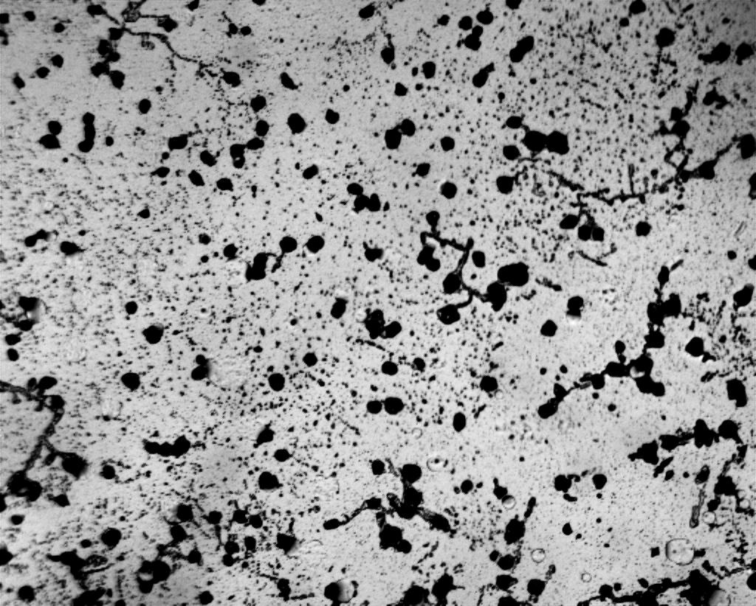

Figure 3c. Growth of large salt crystals.

**4. Sediments at the bottom of a Petri dish two weeks after evaporation of free water**

|  |  |
| --- | --- |
| **C:\Users\1\Desktop\Вода_Стекла\Январь 2022\Инкубация стекла Инкубация стекла в воде\Чашки Петри\Через 2 недели\Впр_1.jpg** | **C:\Users\1\Desktop\Вода_Стекла\Январь 2022\Инкубация стекла Инкубация стекла в воде\Чашки Петри\Через 2 недели\Впр_4.jpg** |
| **C:\Users\1\Desktop\Вода_Стекла\Январь 2022\Инкубация стекла Инкубация стекла в воде\Чашки Петри\Через 2 недели\Впр_5.jpg** | **C:\Users\1\Desktop\Вода_Стекла\Январь 2022\Инкубация стекла Инкубация стекла в воде\Чашки Петри\Через 2 недели\Впр_6.jpg** |
| **C:\Users\1\Desktop\Вода_Стекла\Январь 2022\Инкубация стекла Инкубация стекла в воде\Чашки Петри\Через 2 недели\Впр_13а.jpg** | **C:\Users\1\Desktop\Вода_Стекла\Январь 2022\Инкубация стекла Инкубация стекла в воде\Чашки Петри\Через 2 недели\Впр_17.jpg** |

Figure 4a,b,c,d,e,f. Continuing destruction of DP hydration shells and growth of NaCl crystals.